Ancestors in a familytree
When I started exploring my familytree, I never expected I would find so many ancestors. Every step makes me feel happy like a child in a candyshop. Its a little addictive cause I am so curious about my history and the people who lived here before me. So before I knew I was sitting behind my computer and started to dig deeper and deeper, looking for more and new sources. Then I went to places where they lived and took pics, walking on the same ground they walked and seeing views they might have seen too. It all became so real and they got names.
Next thing that happens is I start to ask myself more and more questions and usually thats the start of a new project. Something I dive in deeper and deeper. Main questions now are:
How did they live, work, what did they eat and drink, what type of houses did they have. In other words:
is it possible to reconstruct the life of my ancestors?
The more recent ancestors are still known by the stories my mom does remember and the archives are more adequat than in the 17-1800’s. There are also many pics taken from grandparents and their names have faces. But the further I go back in time the less there is to be found. There is a tv programm named ‘hidden history’ in which they search the familytree of wellknown Dutch people. Many of them have famous ancestors and lots of stories are kept. In my search I was also curious if there are any famous ancestors and great stories in my familytree.
For many years I only knew my grandparents and the stories about great grandparents. Being busy with my life and raising a family I didnt ever look further back in time. I wrote about the changes in terms of technology and possibilities I have compared to, for instance, my granddad.
--------------------------------------------------------------------------------------------------------------------------------------

Hi Evert, took me long to find you in my family history. Nice to meet you after such a long time.
What a pitty we never met or will meet in person cause I have so many questions to ask you.

1 Evert van Woudenbergh born in 1620 and thats all I can find about you. You must have had a wife cause you had at least one son. I can not find anything about your wife in the archives though. The way our name is written now is different from the familyname you used in 1620 Van Woudenbergh changed over the years to Woudenberg. I can not find where you were born so I have to guess its somewhere near or in Leersum or Overlangbroek like many of my ancestors were. I dont think you had an easy life, hard labour –probably on the land, not much money and I dont think you had a nice and comfortable house either. The best you did for me was to have a son to keep the familytree alive. I really hope to find more information about you, your family and life, so I can get a more complete idea about your life in 1600 and earlier.

In your time (1602) the VOC was founded and the Dutch became famous by travelling and trading with the Eastern part of the world. And Amsterdam had around 100.000 citizens (compared to 850.000 now) I dont think you ever saw the city, no way for you then to walk to get there in those years. The Dutch also build cities in what we now know as The United States of America in 1624. You had no idea while working all day and with only Sundays a little rest to go to church.

Church life in Overlangbroek in 1575 – 1663
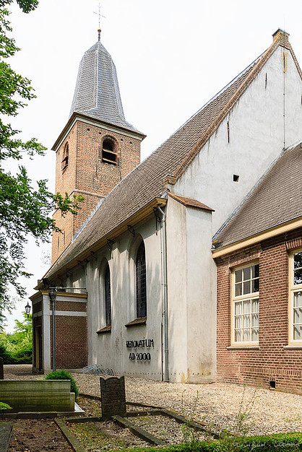
The oldest mention, indicating the presence of the Church in Overlangbroek, is from 1439. St. Hyacinthus would have been the patron saint of the Church. The former "choir" is broken down in 1832. The pulpit is of 1768. The small brass Crown is 1807 and donated by the family of De Kruijff. In 1884 the portal is renewed. In 1913 the consistory was built as it stands as a replacement for the former from 1857. For 1832 the Church had stained glass Windows. These are at demolition work in 1832 presumably sold.
The slab in the porch from 1503, is placed in the wall, located in the "choir". In 1913, the floor of the consistory was opened and then this stone exposed. It was not known, that there was a crypt under this floor. The church tower is in transferred 1851 from the civil municipality to the churchwardens. In 1966 the vault was replaced and the current banks were placed. Previously there was a ' aisle ' by the Church with banks on either side. In 1974, the Spire renewed. In 1978, the stained-glass Windows were put. These Windows are designed by Mr J.M. Meine Jansen. In 1980 there were six copper crowns purchased. The Church has been restored in 2000. The organ was restored in 2007.
In 1429 the Church is first mentioned (to the Holy Hyacinthus) in 1575 the archive starts. In that year Pastor De Kruijff was appointed by the Provost. Six years later, in 1581 the Catholic worship got forbidden by the States of Utrecht. The priests were allowed to stay as long as they would not attack the new learning openly. In 1609 J. Bornius was appointed as first pastor in 1619, he was deposed because he was a Remonstrant.
In 1621 two Overlangbroek farmers took the initiative to get a new pastor to Overlangbroek. They wanted an own preacher and not someone from Wijk bij Duurstede. They wrote a letter to the Classis. The municipality counted 23 compassionate families. At the ' Night time ' (evening ceremony) there were 100 people in the Church. Ds. Bossius came. He has also been Remonstrant. After his departure six inhabitants of Overlangbroek requested to get ds. Drogenbroek. In 1630 they received some money got to fix the preachers house. Ds came in 1632. C.de Leeuw, which usually has designated himself withthe name Leonius. This preacher had made a trip to Brazil behind and told the people about sugar plantations, slave trade and guerrillas. Every now and then he went back to Brazil. His son was a mssionaire there. When Junior preached in the Church the Church was completely filled. He was popular. Under ds. Notelman (1652) everything was quiet.
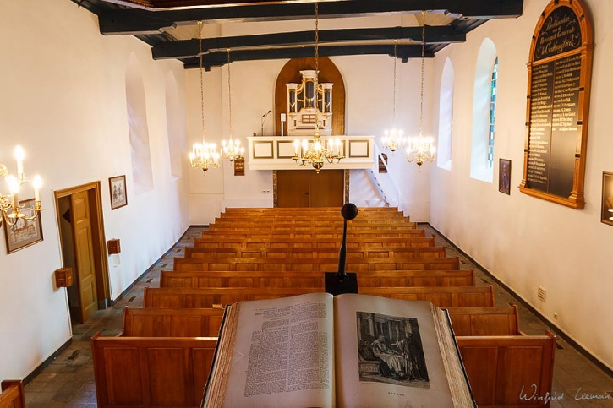
In Overlangbroek there were deacons but no elders. There were too few members. Therefore, the Church was controlled by the classis. And the Reverend went alone to the classis. De sarcristan was in the 17th and 18th centuries, an important figure in the Church community. He was also for singer, mailman fort he municipality , Secretary, gravedigger, often also schoolmaster. De sarcristan was appointed by the councel of Zuilenburg. His income he received from the church members. In 1640 sarcristan J.H. van Dam complained about his low salary. And he did that every year. In addition to his sarcristanship he had earnings as innkeeper. Its successor in 1657, Huijbert van Dam was also proprietor. There were dance parties at his home. In 1663 the jonckspelen (plays for the young ones) were prohibited.
--------------------------------------------------------------------------------------------------------------------------------------

Hi there Huibert, in my search for my ancestors your name popped up. I am glad you left more traces in time than your dad did. I hope he was a good dad for you.

2 Huibert Evertszoon van Woudenbergh 1655 – 1719

Born in a poor family of workers, part of your history is connected to the place Leersum. A place where i found more ancestors of ours. You got married to Dirkje Willems and you had 5 kids as far I can find in the archives. Born in 1680, 1682, 1685 and…. Two born in 1687. Maybe that was a twin, how nice I have two sisters who are twins also. But 5 kids in that time must have been pretty tough, all those mouth to feed.
Your wife died in 1692 at the age of 37 and left you behind with very young kids. I guess the 10 and 12 year old must have helped you in taking care of the household and raising the other kids. You yourself died in 1719 in Leersum at the age of 64 after a life of lots of work and worries. The history shows many facts we still learn in school today, but your world was not that big at that time. The news only spreading to the countryside and small villages by people who were going from village to village to sell stuff, or the ones who transported for instance the wood (people did cut in the fields) by boat to Utrecht.

1672 Year of disaster

1672 France declared, England and Beginning the German dioceses Munster and Cologne war on the Republic. The country was attacked from all sides. Panic broke out and the fear of a total defeat was large.
Together with the English was the French King Louis XIV to the mighty Republic planned to reduce it to a second-rate power. They would land and sea the Republic inflict heavy defeats. To this end, the Treaty of Dover in 1670 they closed. From a logistical point of view were the dioceses Munster and Cologne there asked. In april 1672 Louis declared war on the Republic. He pulled back to the southern Netherlands, which is still in Spanish hands were. He tore through the territory of Cologne along the Rhine and then in June he crossed that river. The French advance was fast: Overijssel, Gelderland and Utrecht were fully occupied. The French could be stopped in the Nick of time by country at the borders of the County of Holland under water. This became known as the ' Dutch water line '.
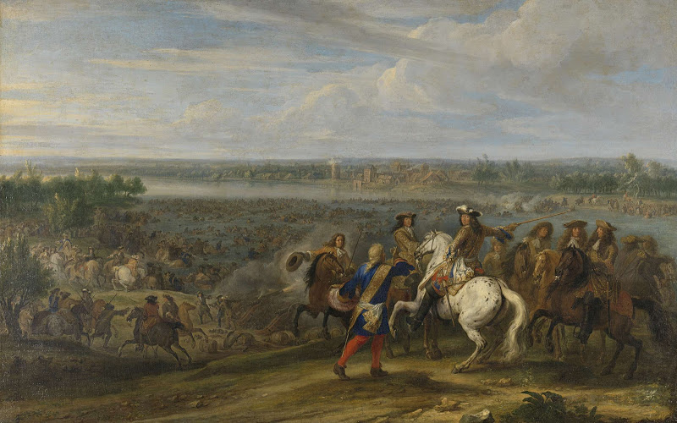
Louis XIV pulls the Rhine at Lobith, 12 June 1672. Adam Frans van der Meulen, ca. 1672-1690

Success at sea

the only successes that the Republic, were recorded in the beginning of the war at sea in the Third Anglo-Dutch war (1672-1674). Unlike the army, the fleet was fairly maintained, though not entirely at full strength. On sea waved Admiral Michiel de Ruyter. He knew the joint French-English fleet to inflict much damage. The battle of Texel (North Holland) in 1673 was the last major. De Ruyter again managed to prevent the landing of enemy troops. The heavily battered French-English fleet withdrew from the war.
William III had a decent army. He drove out the (remaining) enemy of the territory and the peace negotiations could be initiated. There was peace with all parties, but this war was the beginning of the end for the Republic. That is, its leading role in the European economy and politics was over.

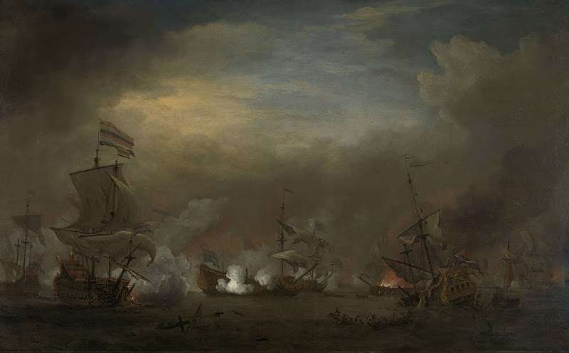
Battle of Kijkduin, 21 August 1673. Willem van de Velde II, ca. 1675

Stories from Churchlife Overlangbroek 1663 - 1717
In Overlangbroek in 1663 was an unmarried mother pregnant for the second time. What to do now with the baptise? It was decided that instead of taking the kid for baptism by others (witnesses) the mother now had to bring the child herself at the pulpit and had to promise from now on such sins to not take place anymore.
Adrianus was going to marry. But then came a hitch. Because Neeltje said she was pregnant and that Adrianus had promised that he would marry her. But Neeltje could show no property on the court hearing in Overlangbroek, which was a tradition in those days. Adrianus finally gave Neeltje money and married his Klaartje instead. For 17th century mixed marriages were common. After that time it became less common. In 1672 Overlangbroek was severely affected by a French invasion. A while there was no church service in Overlangbroek because the people had fled.
Around 1712 there was a preacher (Ter Brugge) who was berating his congregation members regularly. That was to much for the people. Theres said the preacher that E. de Cruijff nor his family, never would enjoy single fruits from their fields and livestock and that God raised him on his deathbed a judgement that would be remembered. He also had threatened him with death. He scolded another calling him Papal dog. The preacher was suspended by the classis. And there will be a process. In 1717 the preacher took the money of the poor people in his own pocket to pay the costs. Because of incompetence and lack of good use of common sense (he also had cursing children) he was dismissed from his tasks. His successor complained about papal naughtyness on the house Donselaar. Where on Sunday three times a Bell was ringing for the Catholic service
--------------------------------------------------------------------------------------------------------------------------------------

The familytree continues with your son Jan who was born in 1687 when you were 32, he was one of the twins by the way.

3 Jan Huijbertsz van Woudenberg 1687 1758

Hi Jan, nice to have found you. You were born in a poor family with 5 kids and i guess you were one of the twins. I supose you were mainly raised by your older brothers and sisters since your mom died when you were only 5 years old. You can not have many memories about her then. Your life started in Leersum but you moved to Overlangbroek fors ure. Maybe there was more or better work to be found for you? In 1730 the potatoe was introduced to Holland till then it was a Southern American product. All the people who were travelling the world seas brought new things to your (our) world. Who could have thought that the potatoe is still now considered as a normal ingredient for Dutch dishes?
You got married to Maaghle Hendrickse van Leer and you got 3 kids, all sons born in 1719, 1721 and 1723. Your wife Maaghje died in 1723 at the age of 36 only. Seems the history repeats itself since the same happend to your dad. Your sons must have been quite a suport to you helping you with making a living by working the land. You died in 1758 at the age of 71

Stories from Churchlife Overlangbroek 1717 - 1731
The new preacher, ds. Kruithof didn't want to be dependent on the classis. Therefore became to the classis a request to start a churches Council. But there had to be enough Biblical knowledge present in the male members of the council. This is doubted by the classis because there also crosses next to the written signatures on the request. The formation of a Church Council was delayed because the wife of the pastor, due to the large debts of her husband, had run away.
After the Church Council was formed, the Reverend demands on his congregation. There came a censorship at the evening supper ceremony for those who had danced until the night to violin music. And labor on Sunday is not desired. His authority took off partly because of his constant debts to members and tot he sarcristan. The sarcristan took the library of the Reverend. Ds. Kruithof had an argument with someone from Wijk bij Duurstede. After that fight was settled he wanted the report of those arguing taken from the minutes. The churches Council refused however.

4 Huybert Janssen Jansz van Woudenberg born in Overlangbroek 1712 died in 1763
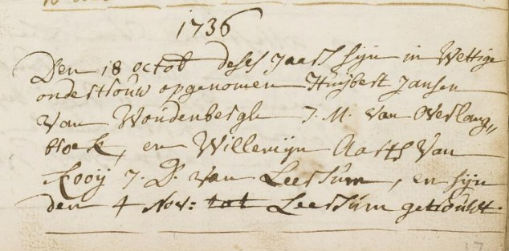
Married to Willemijn Aarts Jansz van Woudenberg (geboren Aartse van Kooij) born in Leersum in 1715 died in 1764 in Hees (probably thats Hees near Soest – there are more places named Soest).

From the old archives:
Meerten Versteeg and Jan Huijbertse van Woudenbergh deacons – van van Overlangbroek have rented Church Council on 27 september 1734 to Cornelis van Ommeren for den Nellesteijn house — time of 3 or 6 years for the summary of 46 guilders. On 10 may 1739 is referred to by the parish receiving 4 gulden posted as receipt of Anthonie van P on the lease on vant house on Nellesteijn. On 27 december 1739 charged Cornelis van Ommeren 28 guilder on the vanNellesteijn about The huiswordt pagt jaer 1738. starting from May 1st 1751 apparently rented by Arie P. SAKRUHArch KerkenraadNHgem. No. 1 Wijk bij Duurstede.

27 sept 1734; To the decision taken by the Church Council regarding the letting of den huijse Nellesteijn, has given the delfshaven Rotary Club to do so in full load and at the Deacons namely Meerten Versteeg and Jan vanWoudenbergh n Huijbertse to the front of Ds dabhade as pastor to rent, as they hetselve him in public with clocks battle rents have in the Church to the highest bidder Cornelis van Ommeren for den time of 3 or 6 years for the somma of 46 guilder right out of the huurcedulle can be read. [On 10 may 1739 is referred to by the parish receiving 4 gulden posted as receipt of Anthonie van P on the lease on vant huijsje on Nellesteijn. On 27 december 1739 charged Cornelis van Ommeren 28 guilder on the Nellesteijn about tjaer's pagt 1738. On 29 July 1740 still received by Dirck de Kruijff because of the Apple trees out of the boomgaert on Nellesteijn the somma of 11 guilders and 4 pennies. DiaconierekeningenOverlangbroek. In 1741 betaaltCornelis vullaganti 10 guilders for the Apple trees and 11 guilders on 4th year 1740wegensNellesteijn. the huiswordt from 1 may 1751 apparently rented by Arie P]. SAKRUH Arch Churches Council NH gem. Wijk bij Duurstede in nr 1

They had quite some kids, ten to be precize:

Geboorte van zoon:
Jan Huijbertze van Woudenberg Leersum, Gld., Ned. 24 feb 1737

Geboorte van dochter:
Neeltje Huijberts Zevenhuijsen (geboren van Woudenberg) Overlangbroek (U) 29 okt 1738

Geboorte van zoon:
Aart Huijberts van Woudenberg Leersum 1740

Geboorte van zoon:
Willem Huijberts van Woudenberg Leersum 1742

Geboorte van dochter:
Maaghje Huijberts van Woudenberg Leersum 1744

Geboorte van zoon:
5 Hendrik van Woudenberg 1746

Geboorte van dochter:
Lijsbeth Huijberts van Woudenberg Leersum 1746

Geboorte van zoon:
Aalbert Huijbertsz van Woudenberg Leersum 1752

Geboorte van dochter:
Hendrikje Huijberts van Woudenberg Leersum 1754

Geboorte van dochter:
Mijntje Huijberts van Woudenberg Leersum 1755

Stories from Churchlife Overlangbroek 1731 - 1749
After that the minutes are missing for a long time because they were written on loose papers. In 1731 came Ds Daverveld. He wanted less strict censure morem as his predecessor. He wanted to keep his congragation together and not lose it. The authority of the Overlangbroekse preacher was low. He planned council meeting a few times, to which no one came. (must be said that this was during the grain harvest) And another time the pastor wanted to show the church to the guests. But the sarcristan refused to give the key of the Church. For this malice the sarcristan got reprimanded by the classis.
Superstition prevailed among the population. Children had to be dewitched if they were Bewitched. In Soest a child was dewitched by a priest. The sarcristan also had his child dewitched by this Pastor. The child cured. And the Catholics said: you see, we have the true faith. Reverend Daverman ignored the fact that The sarcristan was involved in that case. He didnt want to create arguments with the family of The sarcristan.

--------------------------------------------------------------------------------------------------------------------------------------

5 Hendrik van Woudenberg, probably born in Overlangbroek in 1746 and died in 1806 on a not known date. Married to Maria van Borne, date of birth and death both unknown.

In those years Overlangbroek had around 100 citizens. Most people were working on the lands, cutting trees and didnt have much money. Its the same like it is in this time, rich and poor as a topic. The rich had quite some money and the poor ones worked for the rich ones to make a living. Small villages were a bit isolated from the outside world and what was going on there. Daily life was wake, work and sleep seven days a week. On Sunday people went to church that was for many centuries and later also Reformed which caused a split between the two religions and the people belonging to one of the group s. Church, God and social control were quite important to people, everybody knew each other cause of the small community and the dependancy people had towards each other. Hendrik was a worker and did rent a small piece of land to have income. I am pretty sure he was a religious man his wife…… probably also worked on the land to make life a bit easier, two can do more than one. They had at least two sons Jan, born in 1783 and Willem born in 1784 both in Overlangbroek.
In the old documents its written that they were poor people, not able to pay taxes. So they lived in a small world and at the same time in the big world a lot was going on.
From the old archives:

-30 sept 1767; The schout, and the incumbent schepenenAelbert daware, JochemLockhorst, Hendrick van Sterkenburg (which lives outside tgerecht) and loco mortuo Willem de Cruijff, nominate for the upcoming year 1768 respectievelijkWillem Dar on den Roeter, Jochem Lokhorst, Jan van Ingen, Aalbert de Kruijff, Hendrick van Salamanca or Erris van Amerongen, from which deDomheer who was on 13 January 1768 popular on account of has to eligerenAlbert as aldermen daware , Jochem lockhorst, Hendrick van Sterkenborg, Willem de Kruijff and Hendrick vanWoudenberg and to k.g den schout of rays and Albert the URKruijff.HUA Dom no 2324.
24 Oct 1770; William De Kruijf on the Roetert as sitting ships nominates Cornelis van to be geeligeerd by the Provost to Habib to ships. Willem de Kruijff is then on 11 febr k.r geeligeerd 1771 to ships and after nomination by Hendrick vanWoudenberg. HUA DOM 2324

24 dec 1770; The schout, and the aldermen Jochem lockhorst, Hendrick van Sterkenburg, Hendrick van woudenberg, Willem de Kruijff on de Roeter and Jan van Ingen nominate respectively Aelbert de Kruijff, Jochem Lokhorst, Willem de Kruijff, Cornelis van Hamersveld and Erris van Amerongen, from which the Canon on 11 February 1771 eligeert then to about the year 1771 to serve as ships: Jochem Lokhorst, Hendrick van Sterkenburg , Hendrick van woudenberg, Willem de Kruijff and Jan van Ingen and as Church masters de schout Viljoen and Willem de Kruijff. [Jochem Lammers on november 24, 1776 under the incumbent aldermen who nominate for the coming year new, same 1 december 1778]. HUA Dom no 2324.
9 dec 1771; The rear respectively the aldermen Jochem Lokhorst, Hendrick Salang, Willem de Cruijff, Hendrick vanWoudenbergh and Jan van Ingen, nominate as aldermen for the upcoming year 1772 successively Aalbert the Cruyff, Aalbert de Cruijff, Willem de Cruijff, Cornelis Habib, Arris of Amerongen and HendrickWoudenberg to it by the Canon new aldermen to eligeren. HUA Dom no 2324.
Henry Walter explains on 30 January 1773 1773 inbound May 1st to have rented from Baltasar Constatine baron van Lijnden Lord of Lunenburg seeckere daggeldershuijsinge with the hofje in doing so, to Wijk bij Duurstede, now inhabited becoming situated at Jan van Eijsendijk, for the time of 6 years to 28 guilders per year. The tenant will have to keep the chimney from the Wainwright Dyke and well to monitor the forests of the landlord. The tenant will be the four-year willow wicker may enjoy in the orchard and along the dike. SAKRUHNot Amerongen nr 174.
Jan vigil explains on 19 april 1773 with effect from 1 may 1770 to have leased from the pastor and parish of huijsinge and achterhuijs with desselfs seeckere Wijk bij Duurstede in Orchard and tomorrow or Wah along large 2 tomorrow, located under hetselve bijHendrikWoudenberg Rijnwaarts as formerly in Wijk bij Duurstede to hure is used only the hofje exemt (except) that between the House and backhuijs leijt and at the last drawn and this for 6 years to 44 guilders per year. SAKRUH Not Amerongen nr 174.

– Monsieur Albertus Duijm, residing in Three mountains on 21 december 1773 to have declares leases to Bartje van Ingen, widow of Bastiaan Lamprecht and her huijsinge with a boomgaartje and a tuijntje zoonWillem Lankford to Rijnwaarts located under now in Wijk bij Duurstede, hure used becoming with Hendrik van woudenberg, and that for the period of 6 years commencing May 1, 1774 annually to 26 guilders. SAKRUH Not Amerongen nr 174.

Hendrik died in Overlangbroek in 1806
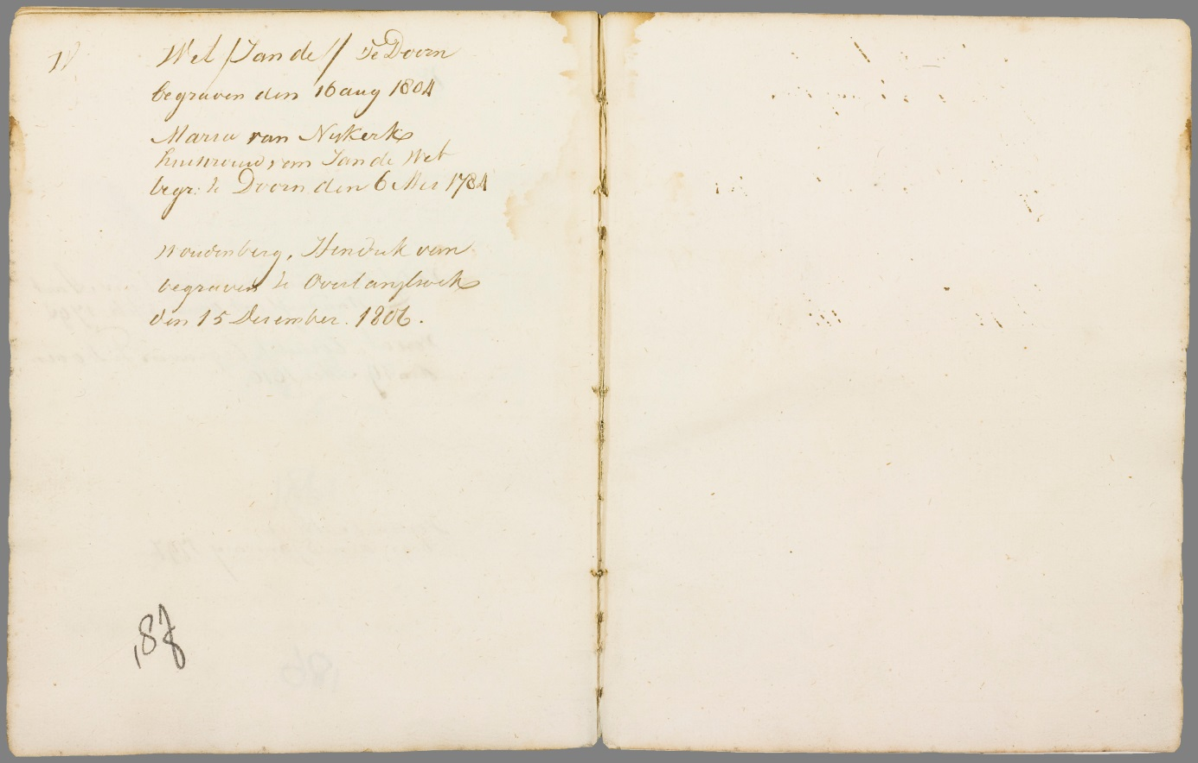
Stories from Churchlife Overlangbroek 1749 - 1773
Dirk de Cruijff was in addition to sarcristan also keeper of the Manor, Castle Zuijlenburg. He was a wellknown guy, but unfortunately he didnt invested his money not so good and thereby he died poor. His cousin bought his house so that his widow could continue living in it. In 1749 William became sarcristan after his father. He didnt listen to the pastors to well. Ds. De Bakker complains that The sarcristan has insulted his wife. In 1807 The sarcristan donates a chandelier for in the Church. Superstition in Overlangbroek also appears in 1773 when a devil exorsist was consulted.
In a process before the Court of Overlangbroekse in 1773, the deacon Arij van Heusden declared that the wife of Willem van Woudenberg had announced to want to see a devil exorsist . The aldermen of Overlangbroek were not surprised. The obviousness of this magic world view shows that the age of the enlightenment in Overlangbroek had not yet led to a rationalisation of the thinking.
(Note: Willem Woudenberg most likely was the brother of Hendrik)
--------------------------------------------------------------------------------------------------------------------------------------
July 13, 1773; Compareerde in ordinary open day in court for SAB and all aldermen: Willem woudenberg, plaintiff in cas of iniuriën, contra Arij van Heusden, defendant. Seijde that the plaintiff defendant Saeed woman hadde geinjureert (slandered), seggende that sij in t House of the ge-challenged outside one's gone, no one at home was sijnde, know that the defendant just after her d was that the woman Walter deselve hebbenmedegenomen, seggende generhande ways salse in time by the Sun fat and not to want to know by sijn woman done, much more to be seen.
Requesting that sijn verklaardwerden by the defendant for honest housewife mountain time by the Sun. The defendant to accuse her in any seijde Davis to blame yet, but itself to refer to the segswijse van eijsch at namentlijck desselfs this done under hair, huijsvrouw, omme, promise to consult with the duivelbanster. SAKRUH DG Wijk bij Duurstede in 1676.eparture hadde missing two fat (straps of the spinning wheel) and so prejurerende able

6 Jan Woudenberg 1783 -1823 (both in Overlangbroek)
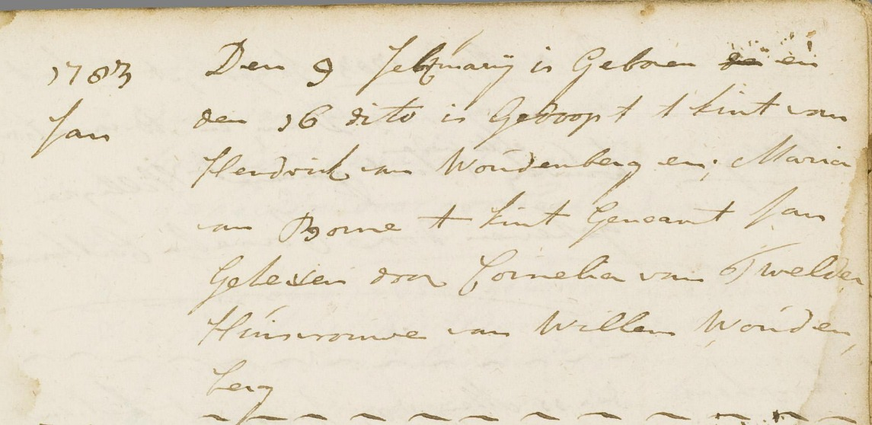
Maria Dekker born in 1786 In Rotterdam, date and place of her death are unknown
Jan and Maria were married on 22 May 1783, but also their son Henry born in 1783. This is a typical issue of ' must '? Very probably, because he was born on 4 May. Both spouses are then already called respectively 40 and 37 years old. From an old baptism overview shows that in 1784 son Willem is born, but in 1786 already passed away.

Batavian Republic (1795-1801)
the French period began in the Netherlands with most of the Batavian revolution in 1795, in which Dutch Patriots, with support of a French army that the country was drawn, the Batavian Republic. William V went to England in exile. After a constitutional change in 1801 the Batavian Republic was replaced by the Batavian Republic.
In the battle of Camperdown in 1797 the Dutch fleet was completely defeated by the British.
In 1799, a British-Russian invasion force North Holland within, captured the Dutch fleet in Den Helder and Alkmaar occupied. The allies, however, were defeated in the battle of Castricum and had to withdraw again from Netherlands Batavian Republic (1801-1806)
Kingdom of Holland (1806-1810)
Louis I of Holland Napoleon Bonaparte, who had proclaimed himself emperor of France in 1804, replaced in 1806 the Batavian Republic by the Kingdom of Holland and put his brother Louis Napoleon Bonaparte on the throne as King Louis I. the Kingdom of the Netherlands also included next to today German East Frisia.
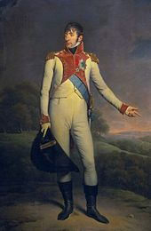
A British army occupied the Zeeland island of Walcheren in 1809, but ran after. A lot of the men became sick and died, and the British withdrew at the end of the year.
In 1809 names Dutch troops to French side part in defeating the German anti-Bonapartist rebellion led by Ferdinand von Schill, at the battle of Stralsund.
Annexation by the first French Empire (1810-1813),
Napoleon, however, was dissatisfied with Louis, which in his view an independent course to enter. In 1810 he decided the low countries at the French Empire. Hoping to preserve the Dutch independence did Louis abdicated and became his young son Louis II, King of Holland on 1 July 1810. Napoleon ignored this action and Netherlands annexed a few weeks later, on 13 July. He appointed Nicolas Charles Oudinot to stadtholder-Prince. That was followed in 1812 by Charles François Lebrun.
About 14000 Dutch conscripts went with the Grande Armée to Russia. The vast majority came to; only very few returned.
The last support points for Napoleon Bonaparte were Maastricht and Delfzijl, which still were besieged until May 1814. See blockade of Maastricht (1814) and siege of Delfzijl (1813-1814).
The French era ended when Napoleon was defeated in 1813 and the throne. The eldest son of William V on november 30, 1813 returned back to Netherlands. After the Congress of Vienna in 1815, he was proclaimed King as William I of the Netherlands.
The most important effects of the French time:
the end of the Dutch Republic and the beginning of the Kingdom of the Netherlands. A centralized polity replaced the decentralized power of the old system.
The final economic victory of Great Britain at Netherlands. Netherlands lost the Cape Colony and the colonies in Guyana and Ceylon to the British. The Dutch East India Company was dissolved in 1798.
Introduction of the first Constitution, the civil code, the civil status, the conscription, the land registry, last names, house numbers and standard sizes and weights: the km, meters and liters.
Creation of the Royal Institute of Sciences, the National Library and the National Art Gallery, the forerunner of the Rijksmuseum.
--------------------------------------------------------------------------------------------------------------------------------------
7 Hendrik Woudenberg 1823 – 1900 Langbroek – Driebergen
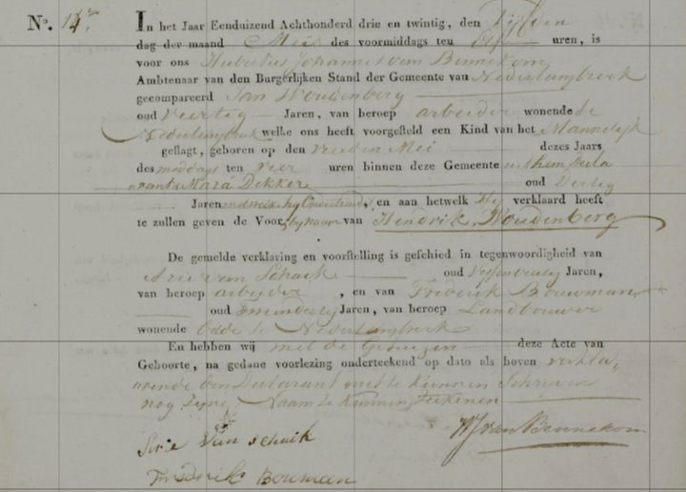
Aaltje Lucasje De Kruijf 1826 – 1892 Maarn – Driebergen
In 1847 he married Aaltje Paul Daniels. Also there is getting married in april and first child in August. That is just slightly too fast I would say so. They get a total of 8 children, three of which death for their parents. Furthermore, it is noticeable that Aaltje at the birth of her last children already far in the 40, 48 at the birth of daughter Maria to be exact. The last born Maria is clearly named after her 2 deceased sisters Maria and Leida.
Geboorte van dochter:
Maria Woudenberg Doorn, Utrecht, Netherlands 17 aug 1847
Geboorte van zoon:
8 Willem Woudenberg Doorn, Utrecht, Netherlands 19 nov 1849
Geboorte van zoon:
Jan Woudenberg Doorn, Utrecht, Netherlands 29 dec 1851
Geboorte van zoon:
Hendrik Woudenberg Doorn, Utrecht, Netherlands 16 aug 1855
Overlijden van zoon:
Hendrik Woudenberg Doorn, Utrecht, Netherlands 26 sep 1856
Geboorte van dochter:
Jannigje Aaltje van Apeldoorn (geboren Woudenberg) Doorn, Utrecht, Netherlands 1 jun 1858
Geboorte van dochter:
Leida Woudenberg Driebergen, Utrecht, Netherlands 6 dec 1862
Overlijden van dochter:
Maria Woudenberg Driebergen, Utrecht, Netherlands 18 sep 1864
Overlijden van dochter:
Leida Woudenberg Driebergen, Utrecht, Netherlands 18 apr 1867
Geboorte van zoon:
Hendrik Woudenberg Driebergen, Utrecht, Netherlands 12 okt 1868
Geboorte van dochter:
Maria Aleida Woudenberg Driebergen, Utrecht, Netherlands 27 mei 1871

Hendrik is born in Overlangbroek and deceased in Driebergen. Son Willem is born again in Doorn. The family seems to travel quite a lot but why they left the vicinity Overlangbroek? Possible because there were better opportunities elsewhere for work, which seems to me still the most likely.

From those ancestors its hard to find anything in archives and pics were not common like in the modern times we live in now. A pic from 1827 is claimed to be the oldest pic ever taken in the world.

‘View from the window at Le Gras-1827’
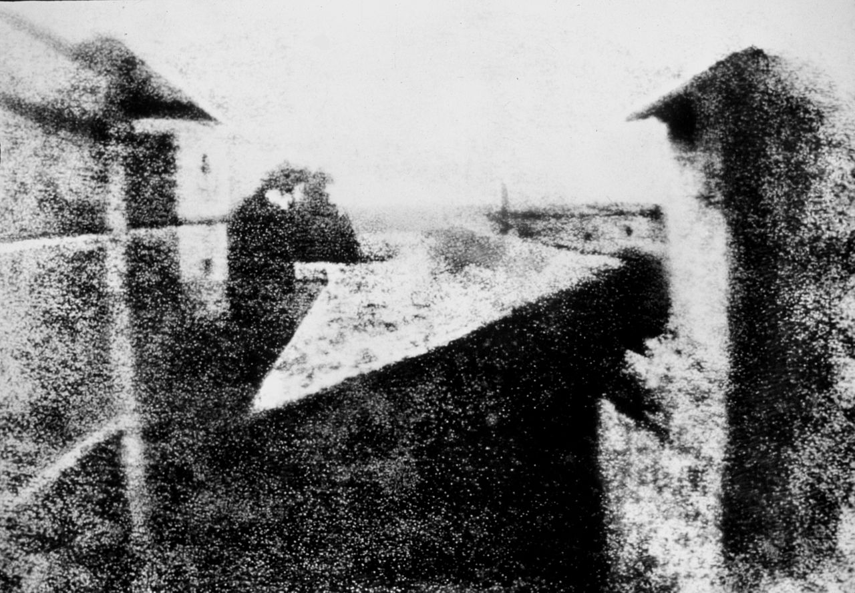
The first pic taken in Holland was in 1839. Theres a lot of discussion about which pic that was. More than one pics are claimed to be the first. So its understandable no pics can be found from ancestors born before then and as it goes with all new technology it took many years before people had acces to it
--------------------------------------------------------------------------------------------------------------------------------------
8 Willem Woudenberg 1849 -1935 Doorn – De Bilt
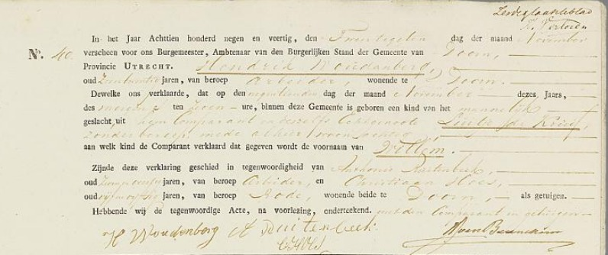
Mietje Lockhorst 1846 – 1923 Langbroek – Maartensdijk
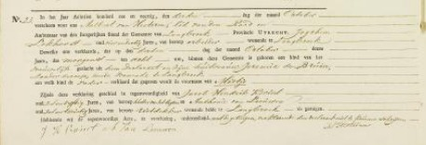
They had a number of eight kids
Geboorte van dochter:
Luitje Woudenberg Werkhoven 3 nov 1873

Geboorte van zoon:
9 Hendrik Woudenberg Werkhoven, Utrecht, Netherlands 30 mrt 1876

Geboorte van dochter:
Maria Versluijs (geboren Woudenberg) Werkhoven 21 jul 1879

Geboorte van zoon:
Johan Woudenberg Werkhoven, Netherlands 12 feb 1881

Geboorte van dochter:
Wilhelmina van Dijk (geboren Woudenberg) Werkhoven 2 nov 1882

Geboorte van dochter:
Jannigje Aaltje Hoogendoorn (geboren Woudenberg) Werkhoven 20 mrt 1884

Geboorte van dochter:
Neeltje van Vulpen (geboren Woudenberg) Werkhoven, Utrecht, Netherlands 21 jul 1886

Geboorte van dochter:
Koosje Woudenberg Werkhoven (Ned) 15 nov 1887 who died one year later in 1888

--------------------------------------------------------------------------------------------------------------------------------------
- Hendrik Woudenberg 1876 – 1946 Werkhoven – Zeist
Hendrik was garden worker and later worked at Bornio in Driebergen? and willemijntje was his housewife. Interestingly, both also come from the region Werkhoven – Leersum. The children are all born in Utrecht and both parents died in Zeist. Seems they moved a number of times. Son Willem has died at a very young age.

Willemijntje van Amerongen 1872 – 1945 Leersum – Zeist
Geboorte van zoon:
Willem WoudenbergUtrecht 15 jun 1901 who died 7 jun 1919
Geboorte van zoon:
10 Aart Woudenberg Utrecht, The Netherlands 20 dec 1902
Geboorte van dochter:
Maria van Soest (geboren Woudenberg) Utrecht, 24 jan 1904
Geboorte van dochter:
Willemijntje Roukens (geboren Woudenberg) Utrecht, 1905
Geboorte van zoon:
Hendrik Woudenberg Utrecht 4 nov 1908

10 Aart Woudenberg Utrecht 1902 – Zeist 1978
Gehuwd met Everdina van Egdom Zeist 1901 - Zeist 1985

Willemijn Woudenberg 1926 – 2009
Johanna Woudenberg 1936 – 1936
Hendrik (Henkie) Woudenberg 1938 – 1944
11 Rijk Woudenberg 1930 – 2003

__________________________________________________________________________________

11 Rijk Woudenberg Zeist 1930 – Werkhoven 2003
Gehuwd met Anna Gerarda van Remmerden Driebergen 1930

Everdina Woudenberg Zeist 1956
Gerda Woudenberg Zeist 1958
12 Arthur Nicolaas Hendrik Woudenberg Zeist 1962
Nicole Hanneke Woudenberg Zeist 1970
Ellen Patricia Woudenberg Zeist 1970

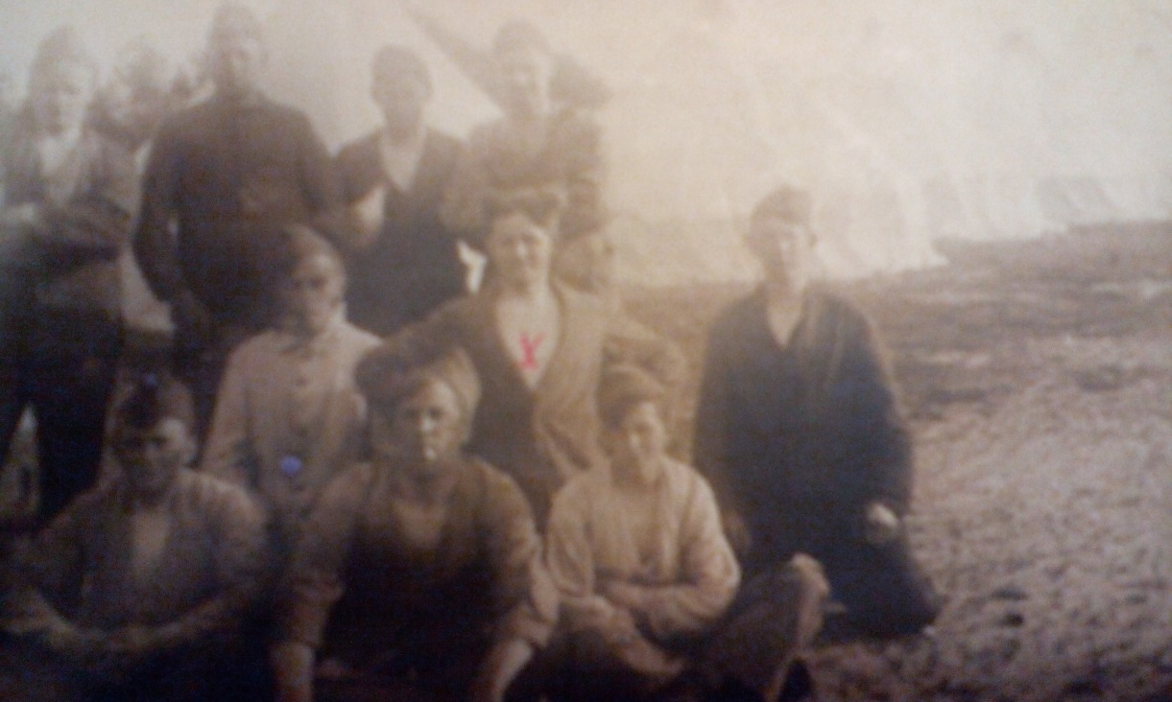

The fighter
My grandfather (the father of my father) was born in 1902. He got married to my grandmother in 1925 at the age of 25. They had a few children, but some did die at a young age (more about that in another post). He always worked in a gas company, hard labour and low salary. He had multiple hearth issues for which he was in hospital many times. His hobbies were making long walks, shooting and breeding birds (especially canaries) and he was quite succesful on that. I still have many medallions he won with his canaries. He was a very religious man, went to church every Sunday and did pay quite some money to the church. We usually went to visit my grandparents on Saturday afternoon and the memories of those visits are nice. He was a very calm man, a bit to heavy and drinking and smoking a little too much in secret. My grandmother was always trying to ‘catch him’ on drinking. But he became quite smart in finding new tricks to hide it.
During Christmas and other occasions he always told nice stories about his service time in the army. He seems to have been a hot tempered man who often ended up in a brawl. After drinking a little alcohol he started to tell the stories about what he has been up to. As a child I listened enthralled to, my tough Grandpa the fighter that hit the corporal with a metal mug. Or the sergeant with the too thin legs that he teased so much that he’d freak out and they ended up in a fight and grandfather spend another night in prison.
They moved to a senior complex where he lived a quiet life. They had a dog and I think all the movement he got was walking the dog. He seemed to enjoy it a lot and when playing cards with people who did visit them he secretly poored himself a new drink without my grandmother noticing.
Then on a cold november morning he went to walk the dog. After some time the dog came home alone and sat barking in front of the door. My worried grandmom went to look where he was and turned out he had a heartattack not far from home and died on the street.
I am happy he was who he was, enjoying his little secret pleasures. And on that november morning, he lost his last battle…it was the end of ‘the fighter’.

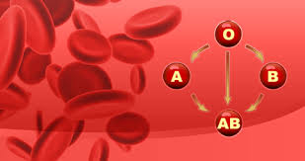
Blood types
In the last century different bloodtypes were discovered around the year 1900. But it took many years before it was common knowledge and was applied. The infant mortality rate was at the beginning of last century in any case higher than now. Many children who died then today would easily survive now
My grandparents have lost two of their children. It was a topic which wasnt discussed in the family, that was ‘normal’ at that time.. Partners also didnt speak much at that time (and that's also still nowadays) about the emotions associated with losses and other significant events. People worked hard, often had poverty and struggling to keep their heads above water. The loss of a child was part of life and it was not something people took time for to give it a place in their life.. So my grandmother lost two of her children.
One of these children was a girl who suffered from a blood disorder. I do not know the exact story but just the main lines and that is has been tragically viewed from the current time. At the time the medical knowledge was more limited than now. Sometimes a blood transfusion in blood diseases was necessary and in the case of my father's sister it was like that too. But a transfusion ' worked …or didnt work '. In her case it didnt work and she died of the effects of the disease. That the transfusion did not pick up. ... came simply because the blood types were not tested at that time. Now unimaginable especially if you think how simple this girl could have survived and grow up.

When my grandfather died, my grandmother moved to an elderlyhome. She had her own room there and was alone a lot. At some point we started to notice weird behaviour. When we took her home after she did visit us, she wanted us to check her room …if nobody was under her bed. She had a small cage bird which she poored water on. The bird needed a shower. And then the nurses told us, that grandmother saw little children playing in the garden of the elderly home. But nobody else saw them kids. And she also said the kids were dressed in black and they were too close to the pond. Maybe she never got over the loss of her babies, we will never know. She died in a nursinghome for alzheimer patients on september 1st 1985 at the age of 84.
I am very thankful sciense did develop a lot over the years. In 1987 my son was born and at a young age he was diagnosed with Evans syndrom a rare blooddisease which caused he needed multiple bloodtransfusions. I guess you can imagine what would have happend if we were living in the beginning of the previous century. But NO we are not…..no, we are not…thank God

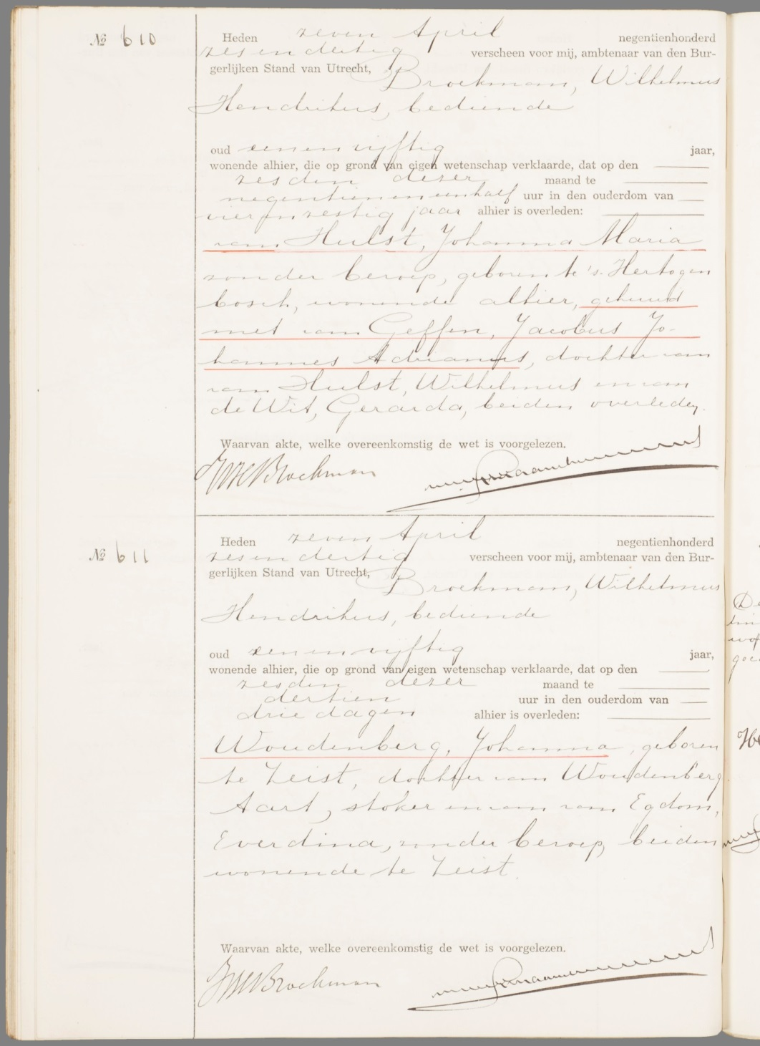

Henkie 1938-1944 The deceased brother of my father
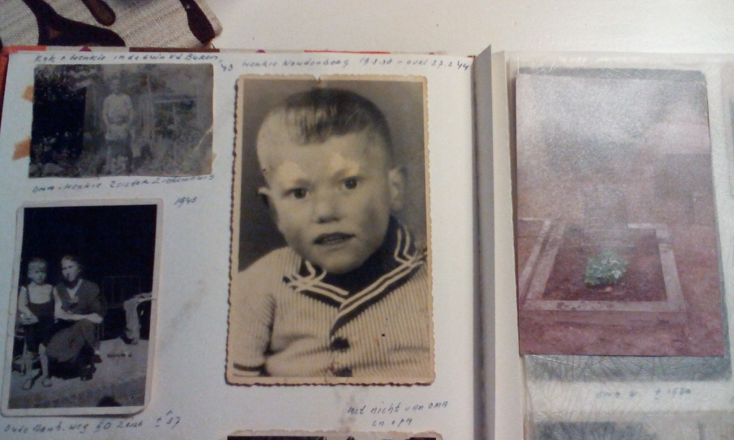
when my father was eight was his little brother Henkie was born. It will have been after a number of miscarriages known and not known. What will Grandpa and Grandma have been happy! On the few pictures that have been preserved I see a cute little boy who cheerfully looks into the world. Unfortunately it Henkie was not healthy and actually seriously ill. Tradition can only tell that his heart and kidneys did not work well. He kept a lot of moisture which by the doctor was drained and in the pit at the House trashed. He may have been in the hospital several times. A silent witness is a picture of Grandma with Henkie in front of the hospital in Zeist (1937). He seems to have been a smart boy who liked wisecracks who benefited most. My father was the same kind and has plagued Henkie also. Later, he said there is regret he did that. In 1944 Henkie died, the only thing left of him rest are few memories, some pictures and his tomb at the cemetery in Zeist.
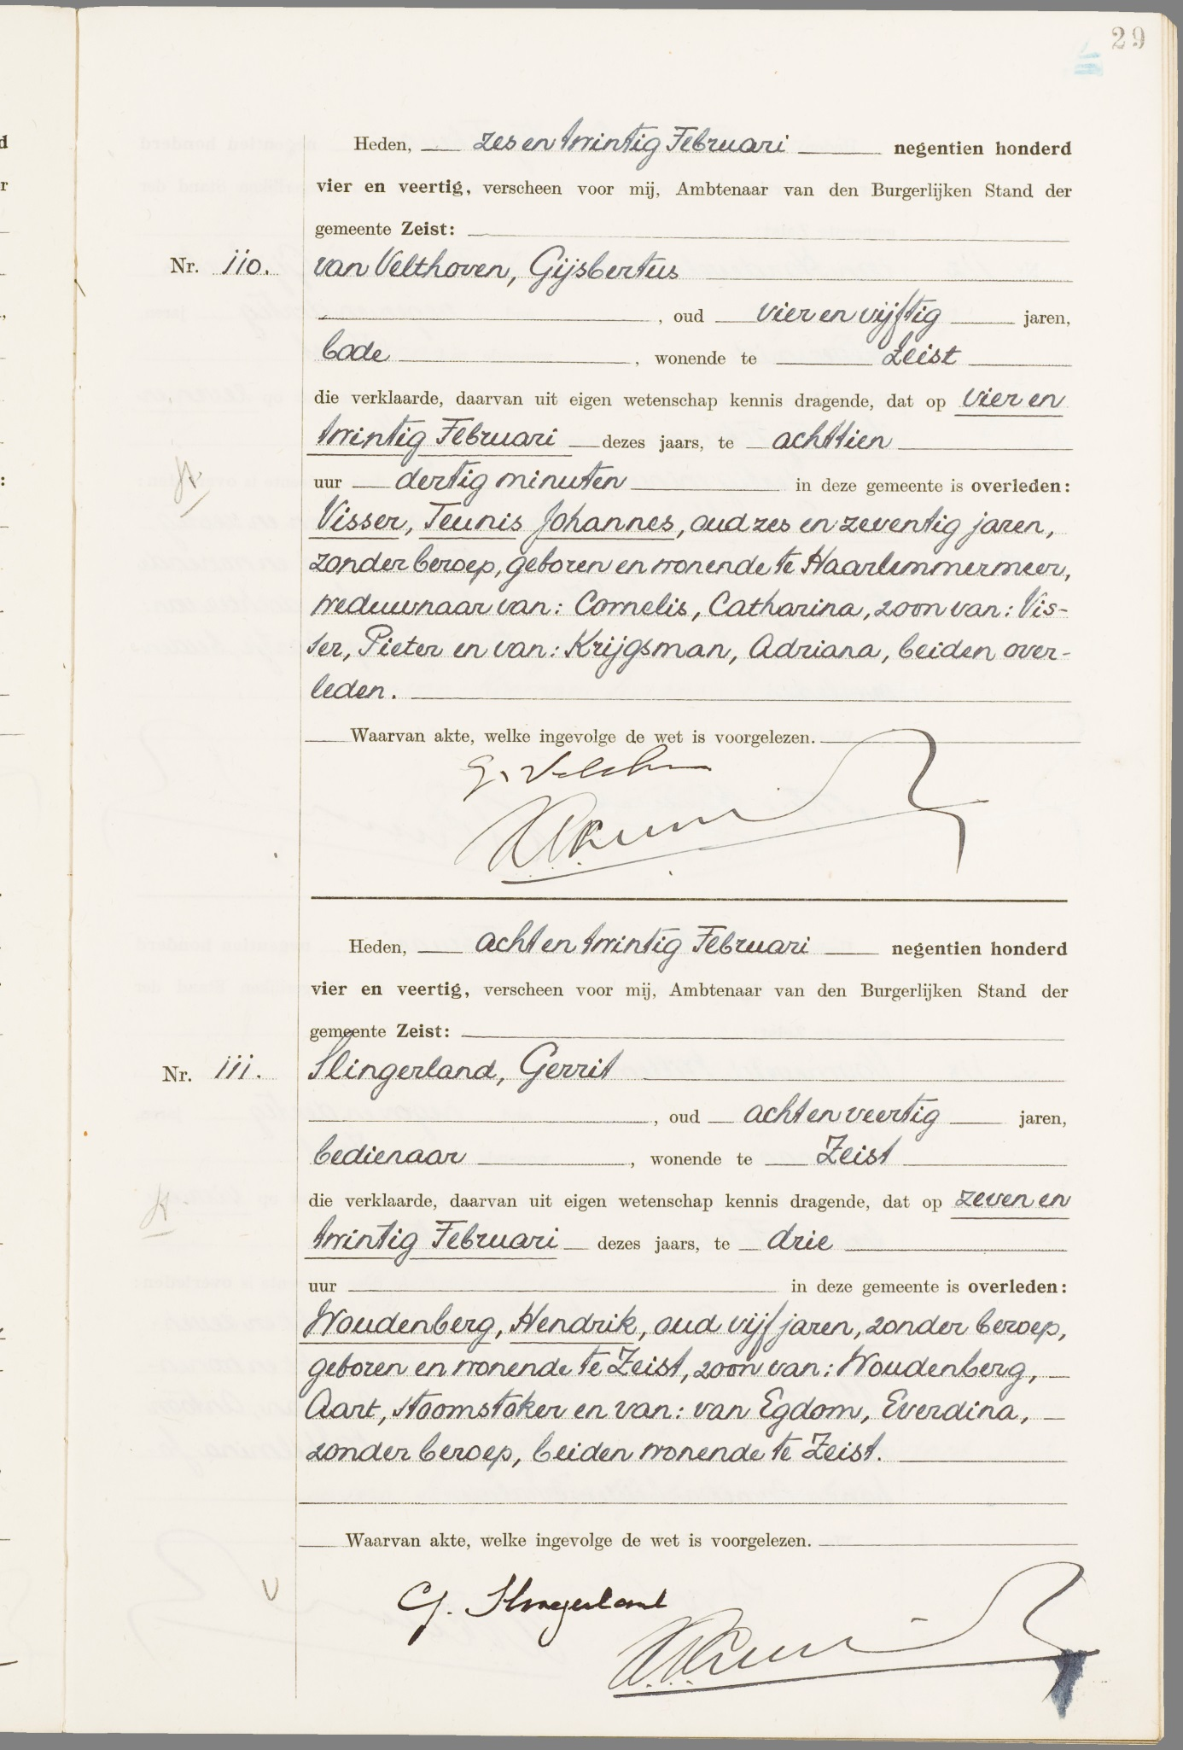

The murder of Willy van Soest 1955
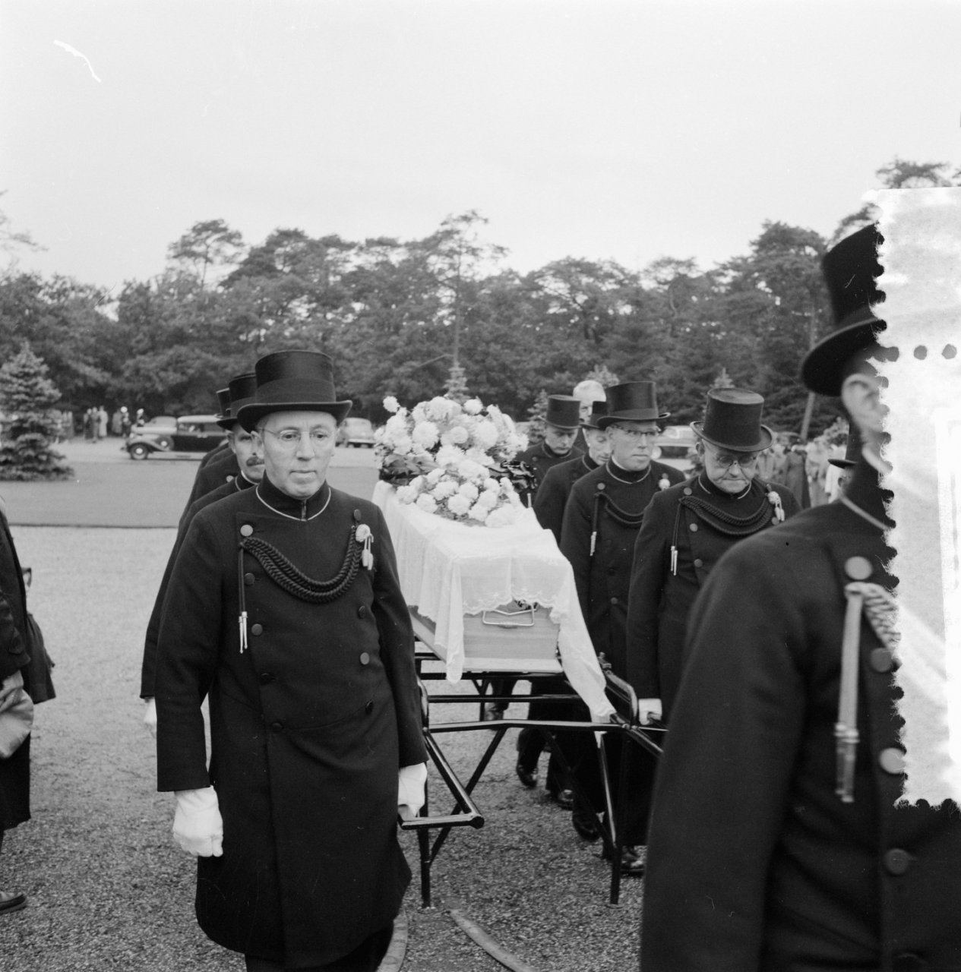
Willy van Soest was the daughter of the uncle and aunt of my father (father's side). She worked as a student nurse in the hospital in Amersfoort? After an evening service on 13 October she went by bus from Amersfoort to Zeist where she lived with her parents. She is, however, never arrived home. She probably came to the Oude Woudenbergse Zandweg against her killer. This was (and is) a somewhat narrow dark Avenue that is located on the edge of Zeist. What exactly happened will always remain unknown. The most likely scenario is that this guy has dragged her in the bushes and sexually assaulted and strangled her there.. The offender is caught and later turned out to be her 29-year-old ex-neighbor, a redhead one ‘eared‘ man. He is declared insane and included in a closed establishment in Breda.
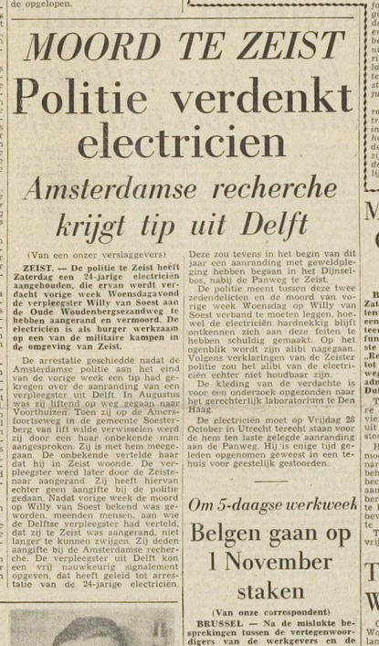
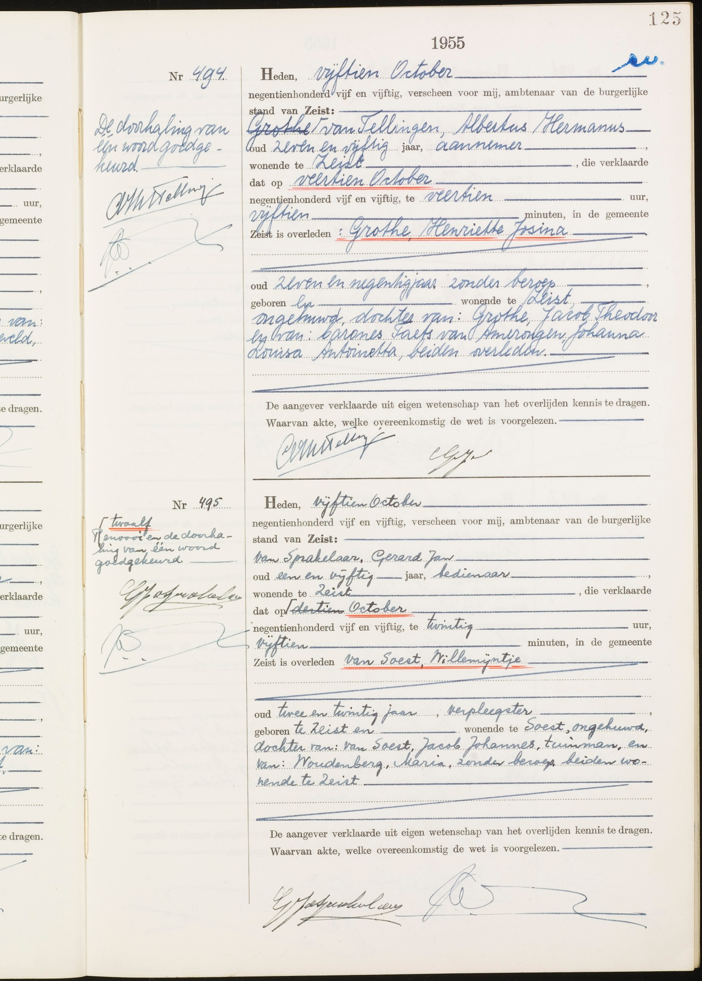

12 Arthur Nicolaas Hendrik Woudenberg 1962
Gehuwd met Carin Woudenberg-Borgers 1961

Anna Jantina (Annabel) Woudenberg Rotterdam 1986
13 Jasper Willem Rijk Woudenberg Rotterdam 1987
Theresia Maria (Tessa) Woudenberg Rotterdam 1989

Jasper Willem Rijk Woudenberg 1987
Gehuwd met Birgit de Koning

Abbygale de Koning Gorkum 2008
14 Quiana Woudenberg Gorkum 2012

